**I used below links to install Wazuh:**

https://documentation.wazuh.com/4.0/virtual-machine/virtual-machine.html

https://www.youtube.com/watch?v=uijZuneDPPk

You can download the OVA package in the below link:

<https://packages.wazuh.com/4.x/vm/wazuh-4.0.3_1.11.0.ova>

Please use Virtual Box to open this OVA file.

**VM username details:**

**Username**: root

**Password**: wazuh

Once you logged please find the IP Addr by issuing “**ip a**” command and note down the ip address.

Open the Browser in your desktop and **https:<<noted IP Addresss>** (please use https)

**Kibana user name details:**

**Username**: admin

**Password**: admin

Once you logged int you will see the Kibana dashboard, in the menu select “Wazuh”

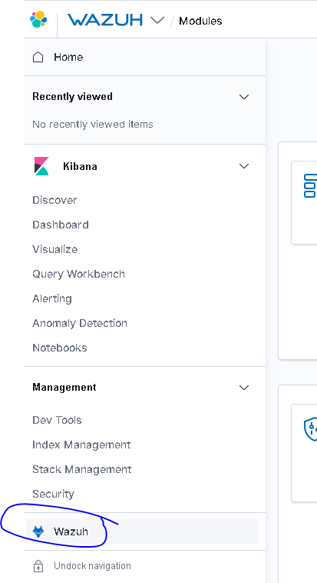

You will get something like below:

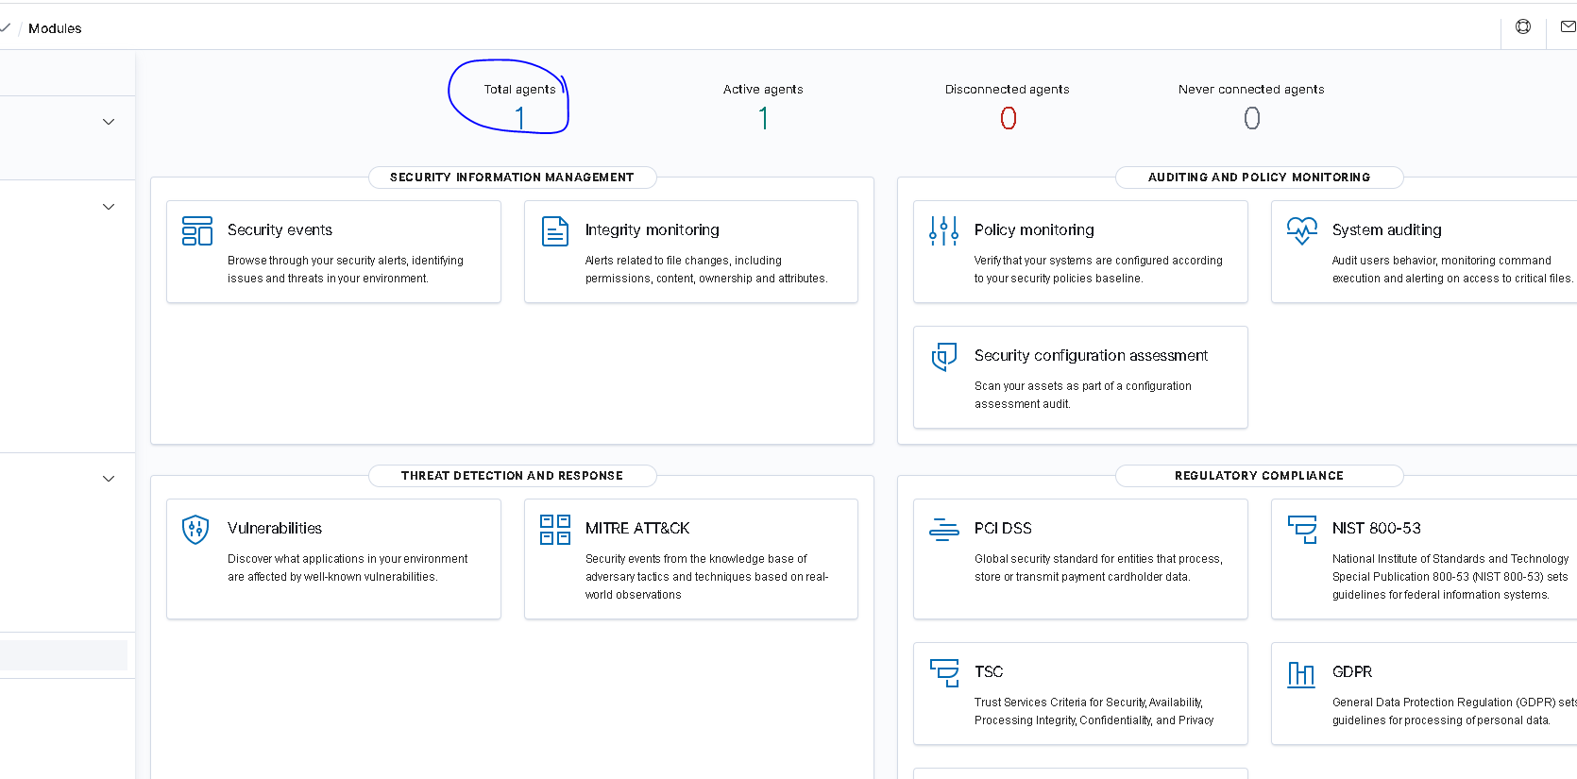

Initially your Agents will show “0” agents running:

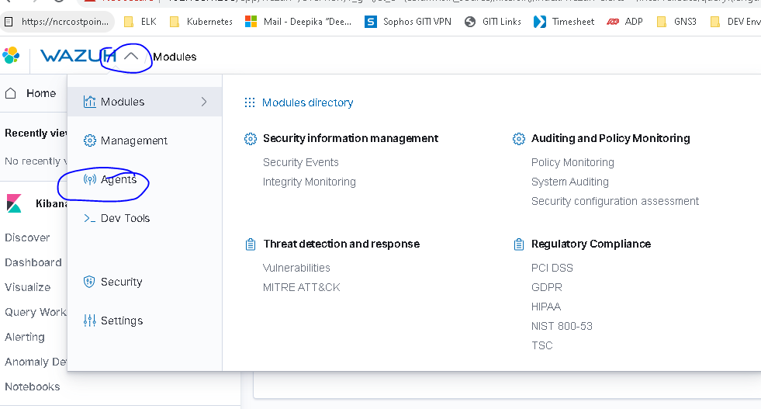

Please select “Agents” from the above link to add more Agents:

In the “Agent” window

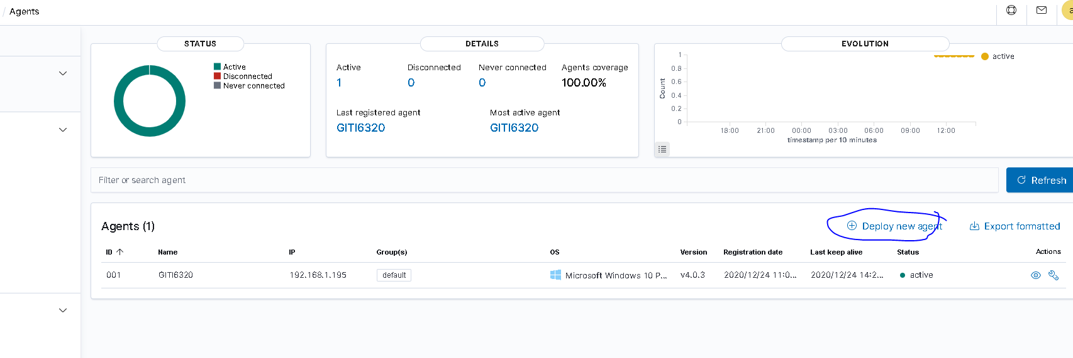

Select “Deploy New Agent”

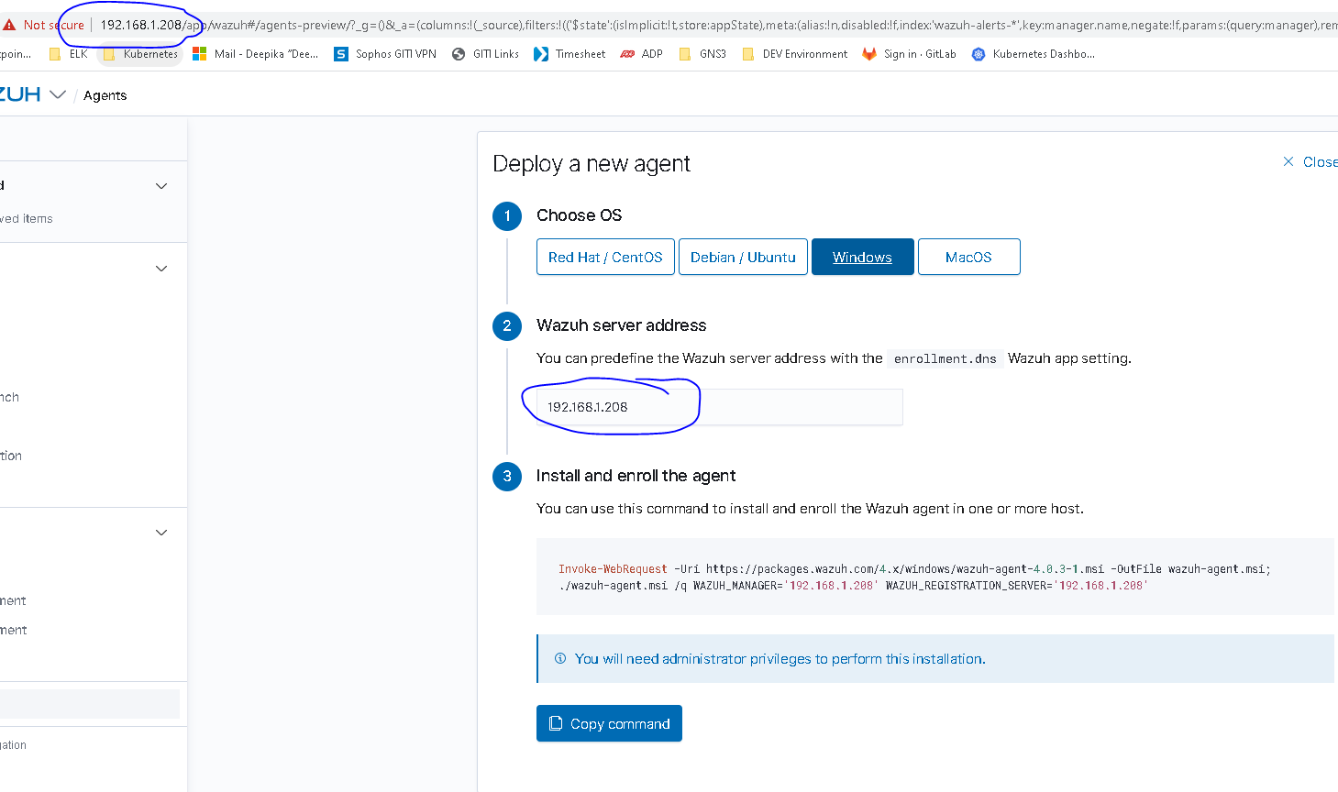

Please change the “localhost” into the Kibana IPAddress, then copy the Command and run that in Powershell (run as administrator). When you refresh the Kibana again. You will see one Agent running.